Respirator Fit Test (Qualitative)
An improper fit of your respirator in a hazardous environment can be dangerous to your health and even deadly in certain situations. Each time a respirator is used, a careful inspection of the device along with a user seal-check is required. Remember that your respirator is the last line of defense against a potentially toxic atmosphere and it should be kept meticulously clean and in adequate working order. The following protocol describes the actions that should be taken when donning a respirator:
Respirator Inspection Steps
- Insure that the respirator and filter cartridge(s) selected meet the requirements for the particular airborne contaminant(s) and their concentrations, and that the respirator is sized as per your respirator fit-test.
- Insure that new filter cartridges are of the same manufacturer as the respirator and that they fit snugly into position.
- Check the rubber or silicone face-piece for cracks, tears, excessive stretching, and deterioration. If a nose-cup is being used in a full face respirator, it should be removed for inspection and cleaning.
- Inspect all straps for deterioration, cuts, splits, and over-stretching. See that the connecting hardware is serviceable.
- Check the inlet and exhaust diaphragms for stiffness and brittleness by removing each diaphragm from the valve and rolling it between your fingers. Then drop it into your hand to check pliability. The diaphragm should return to the flat position. Carefully re-install the diaphragm or install a new one as required.
- Visually inspect both the exterior and interior of the respirator for debris and cleanliness.
- If a full-face respirator is being used, insure that the face shield is clean and free of abrasions.

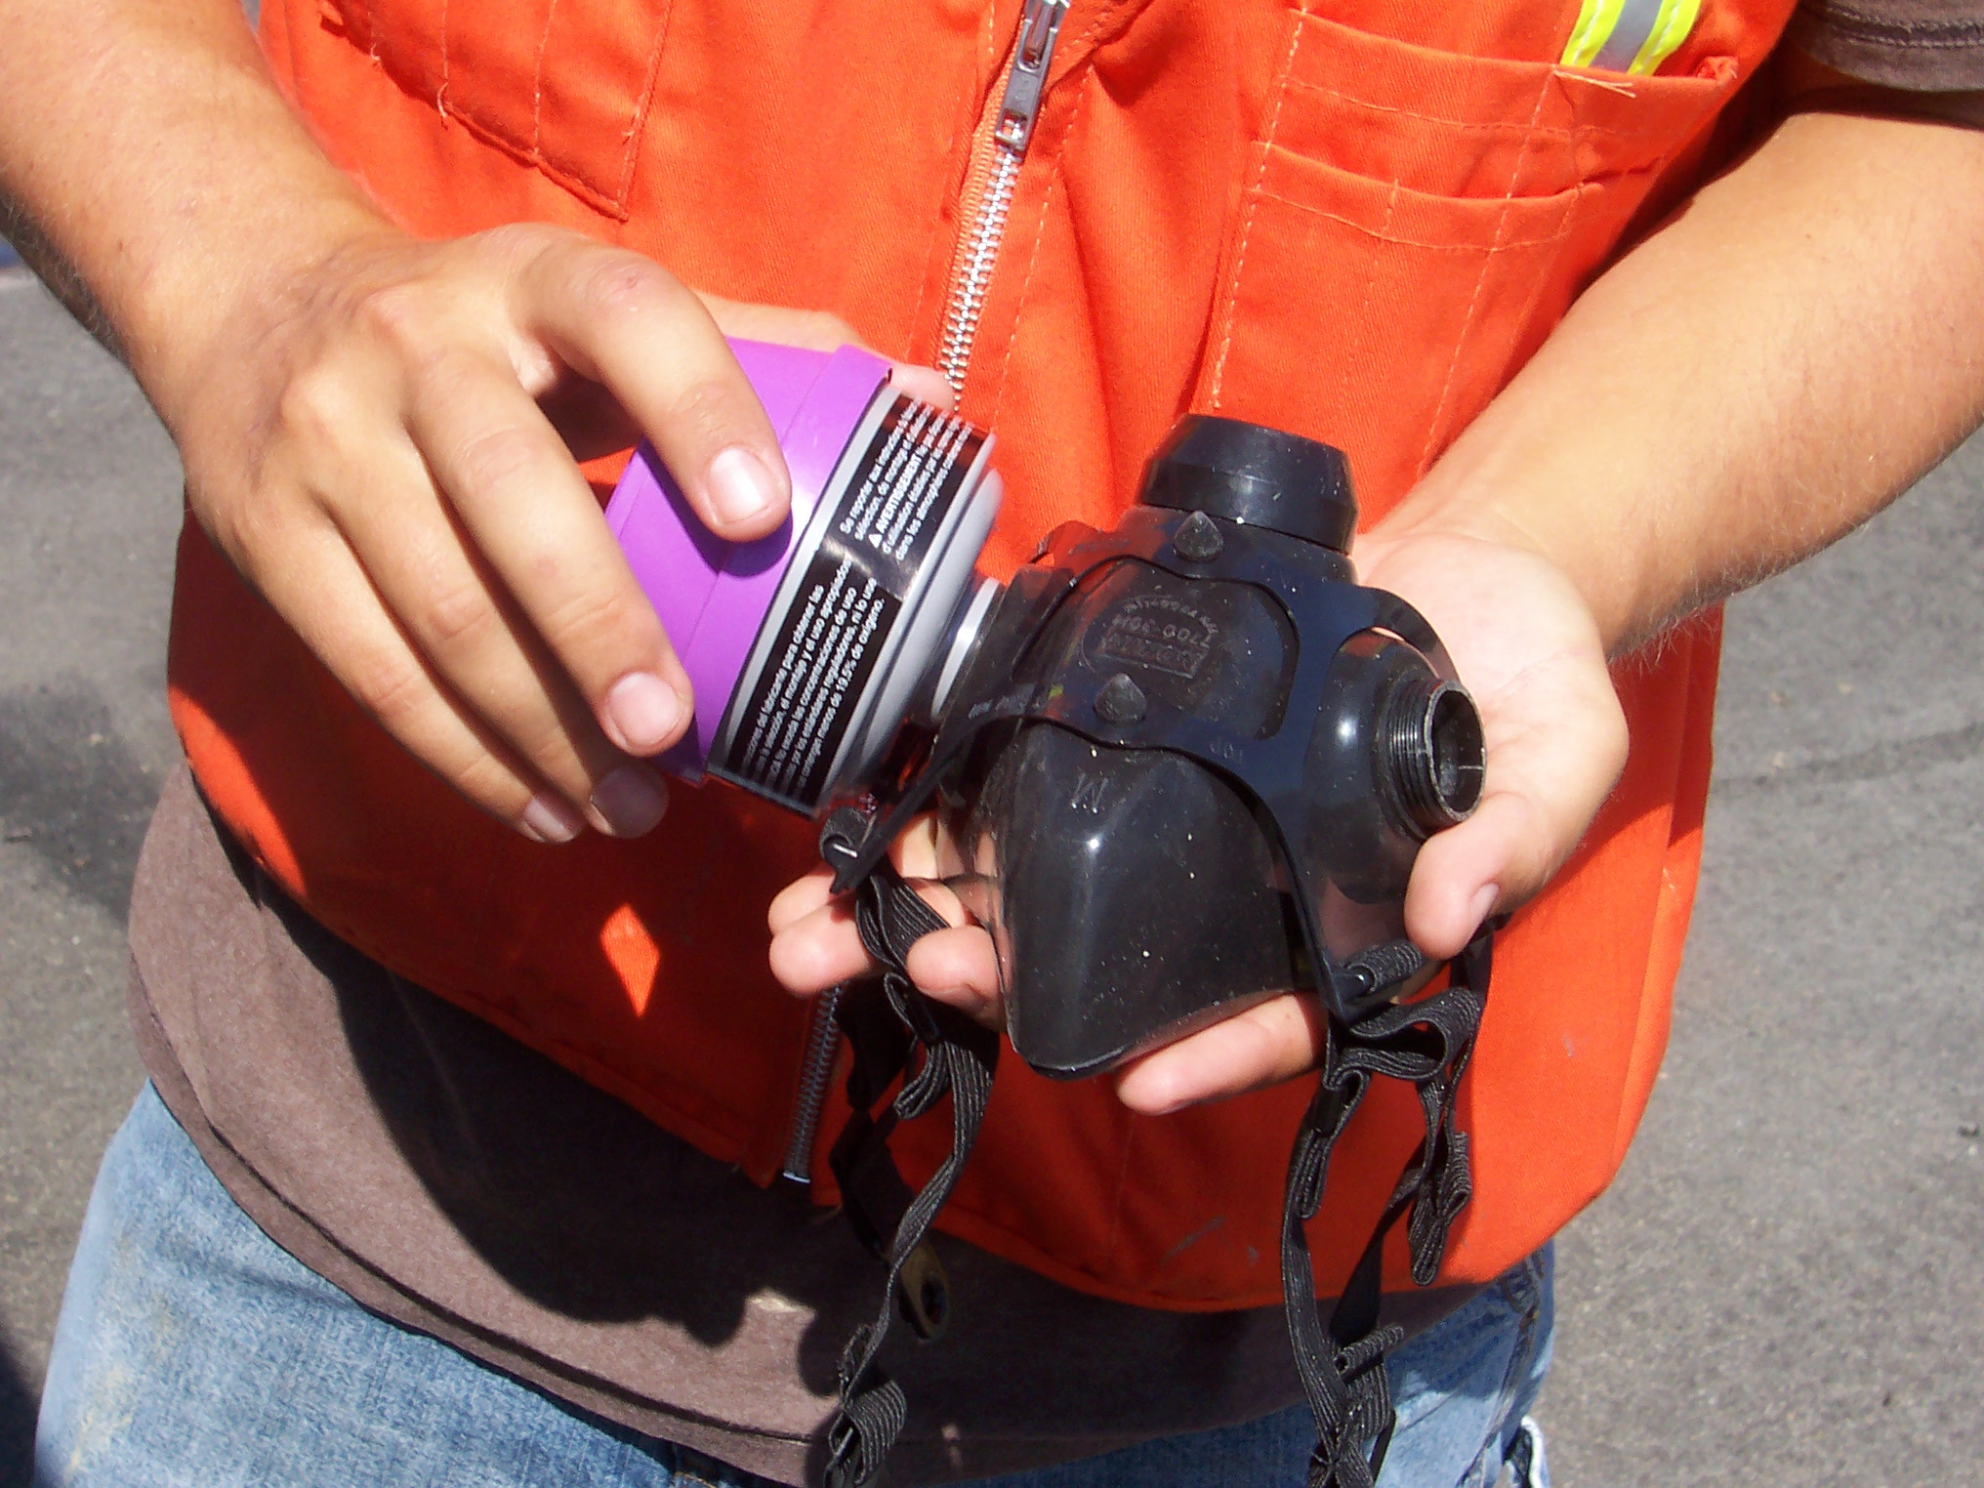

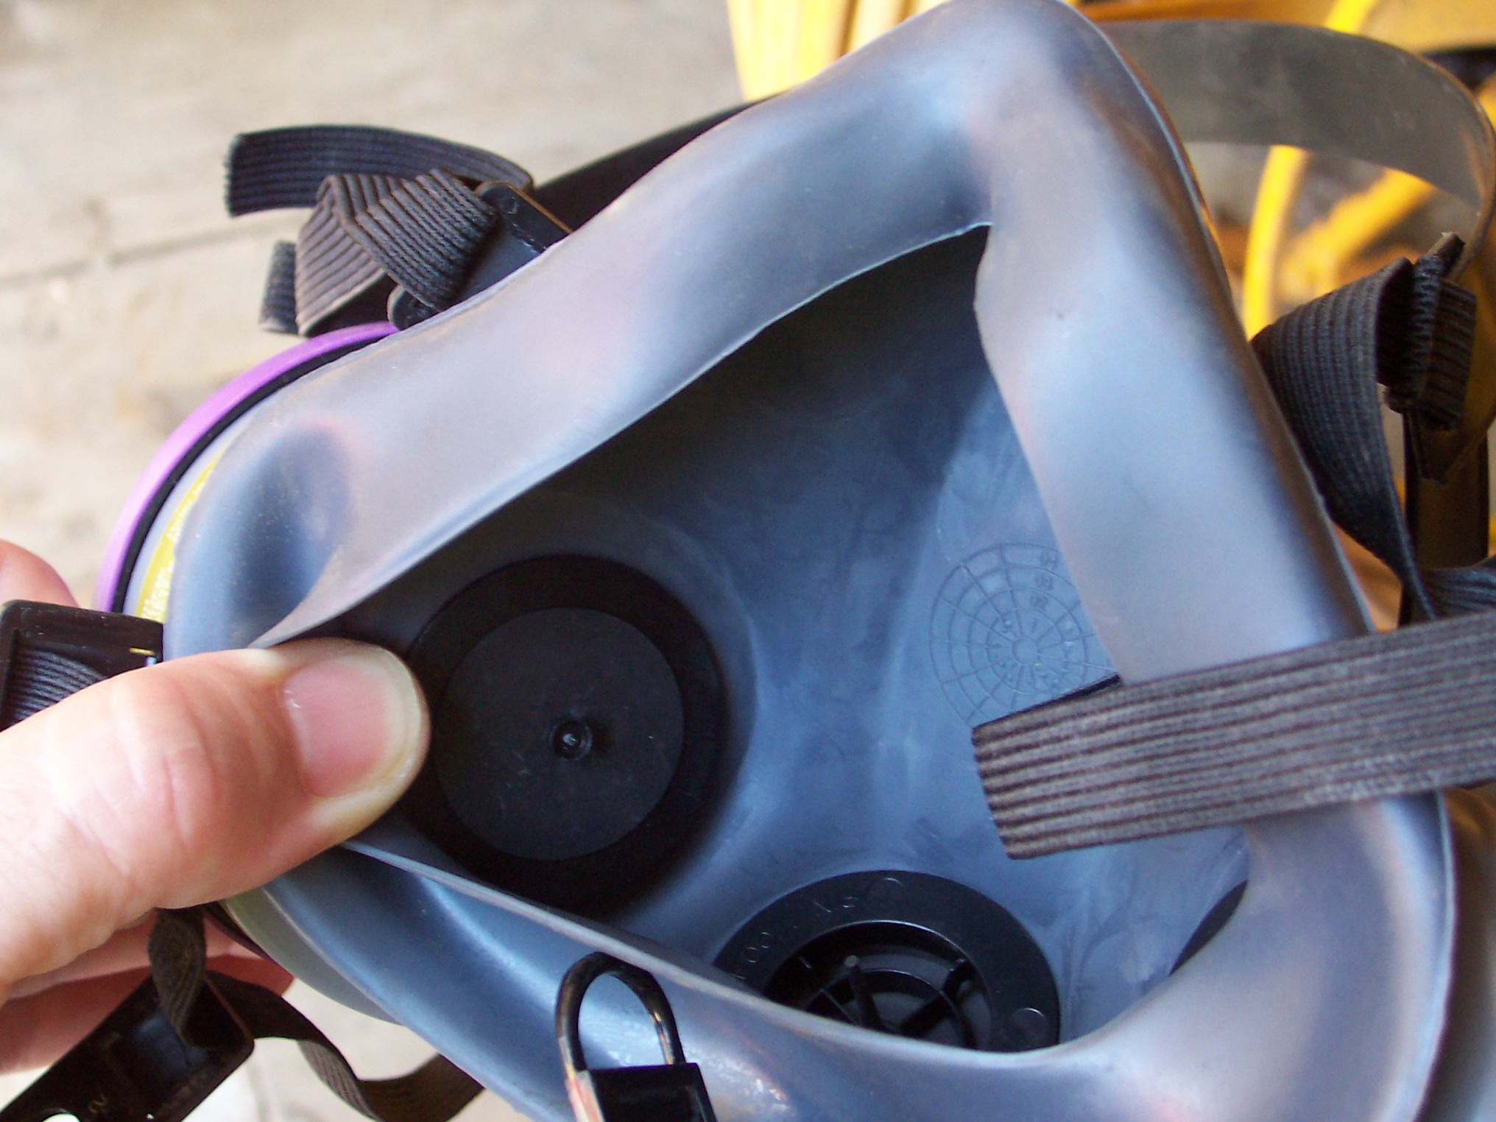
Performing a User Seal-Check
Appendix B-1 to 29 CFR 1910.134 makes it clear that an individual who uses a tight-fitting respirator is to perform a user seal check to ensure that an adequate seal is achieved each time the respirator is donned. Either the positive and negative pressure checks listed below or the respirator manufacturer’s recommended user seal check method must be used.
The positive and negative pressure check is performed by blocking first the inhalation valves while attempting to draw air into the respirator (through the cartridges), then blocking the exhalation valve while attempting to exhale through the respirator. While the filter cartridges are covered, the mask should collapse on your face during inhalation. Hold this negative pressure for 3 to 5 seconds to insure a good seal. If a leak is detected, re-adjust the straps which are closest to the leak and repeat until no further leakage is detected. Latex or nitrile gloves may provide a better sealing surface between the palms of the hands and the respirator cartridges while performing this (negative pressure) check.
The positive pressure check is performed by blocking the exhalation valve and gently exhaling into the mask. Resistance should be felt and a positive pressure should be apparent to the respirator wearer prior to the mask lifting off the face to release the pressure. The respirator manufacturer’s recommended procedures for performing a user seal check may be used instead of the positive and/or negative pressure check procedures, provided that the employer demonstrates that the manufacturer’s procedures are equally effective.

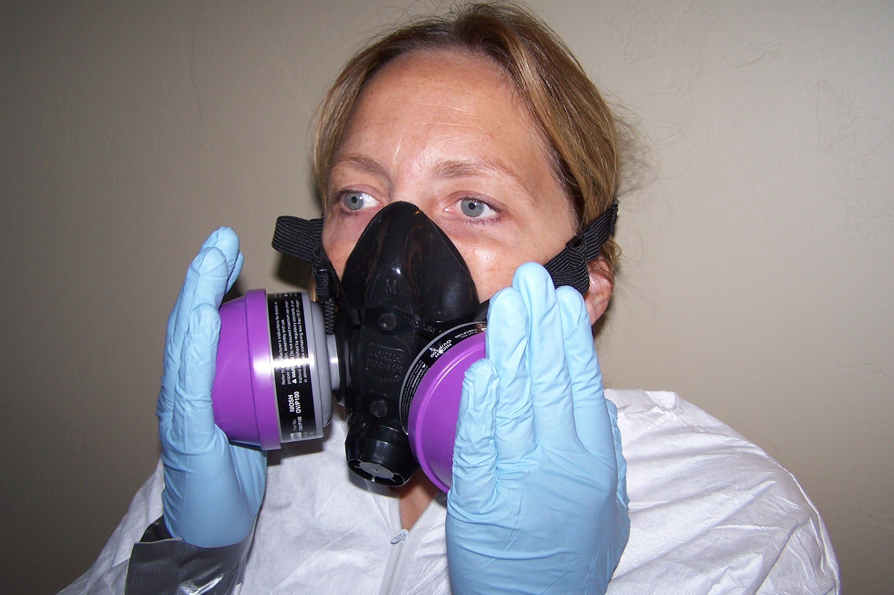

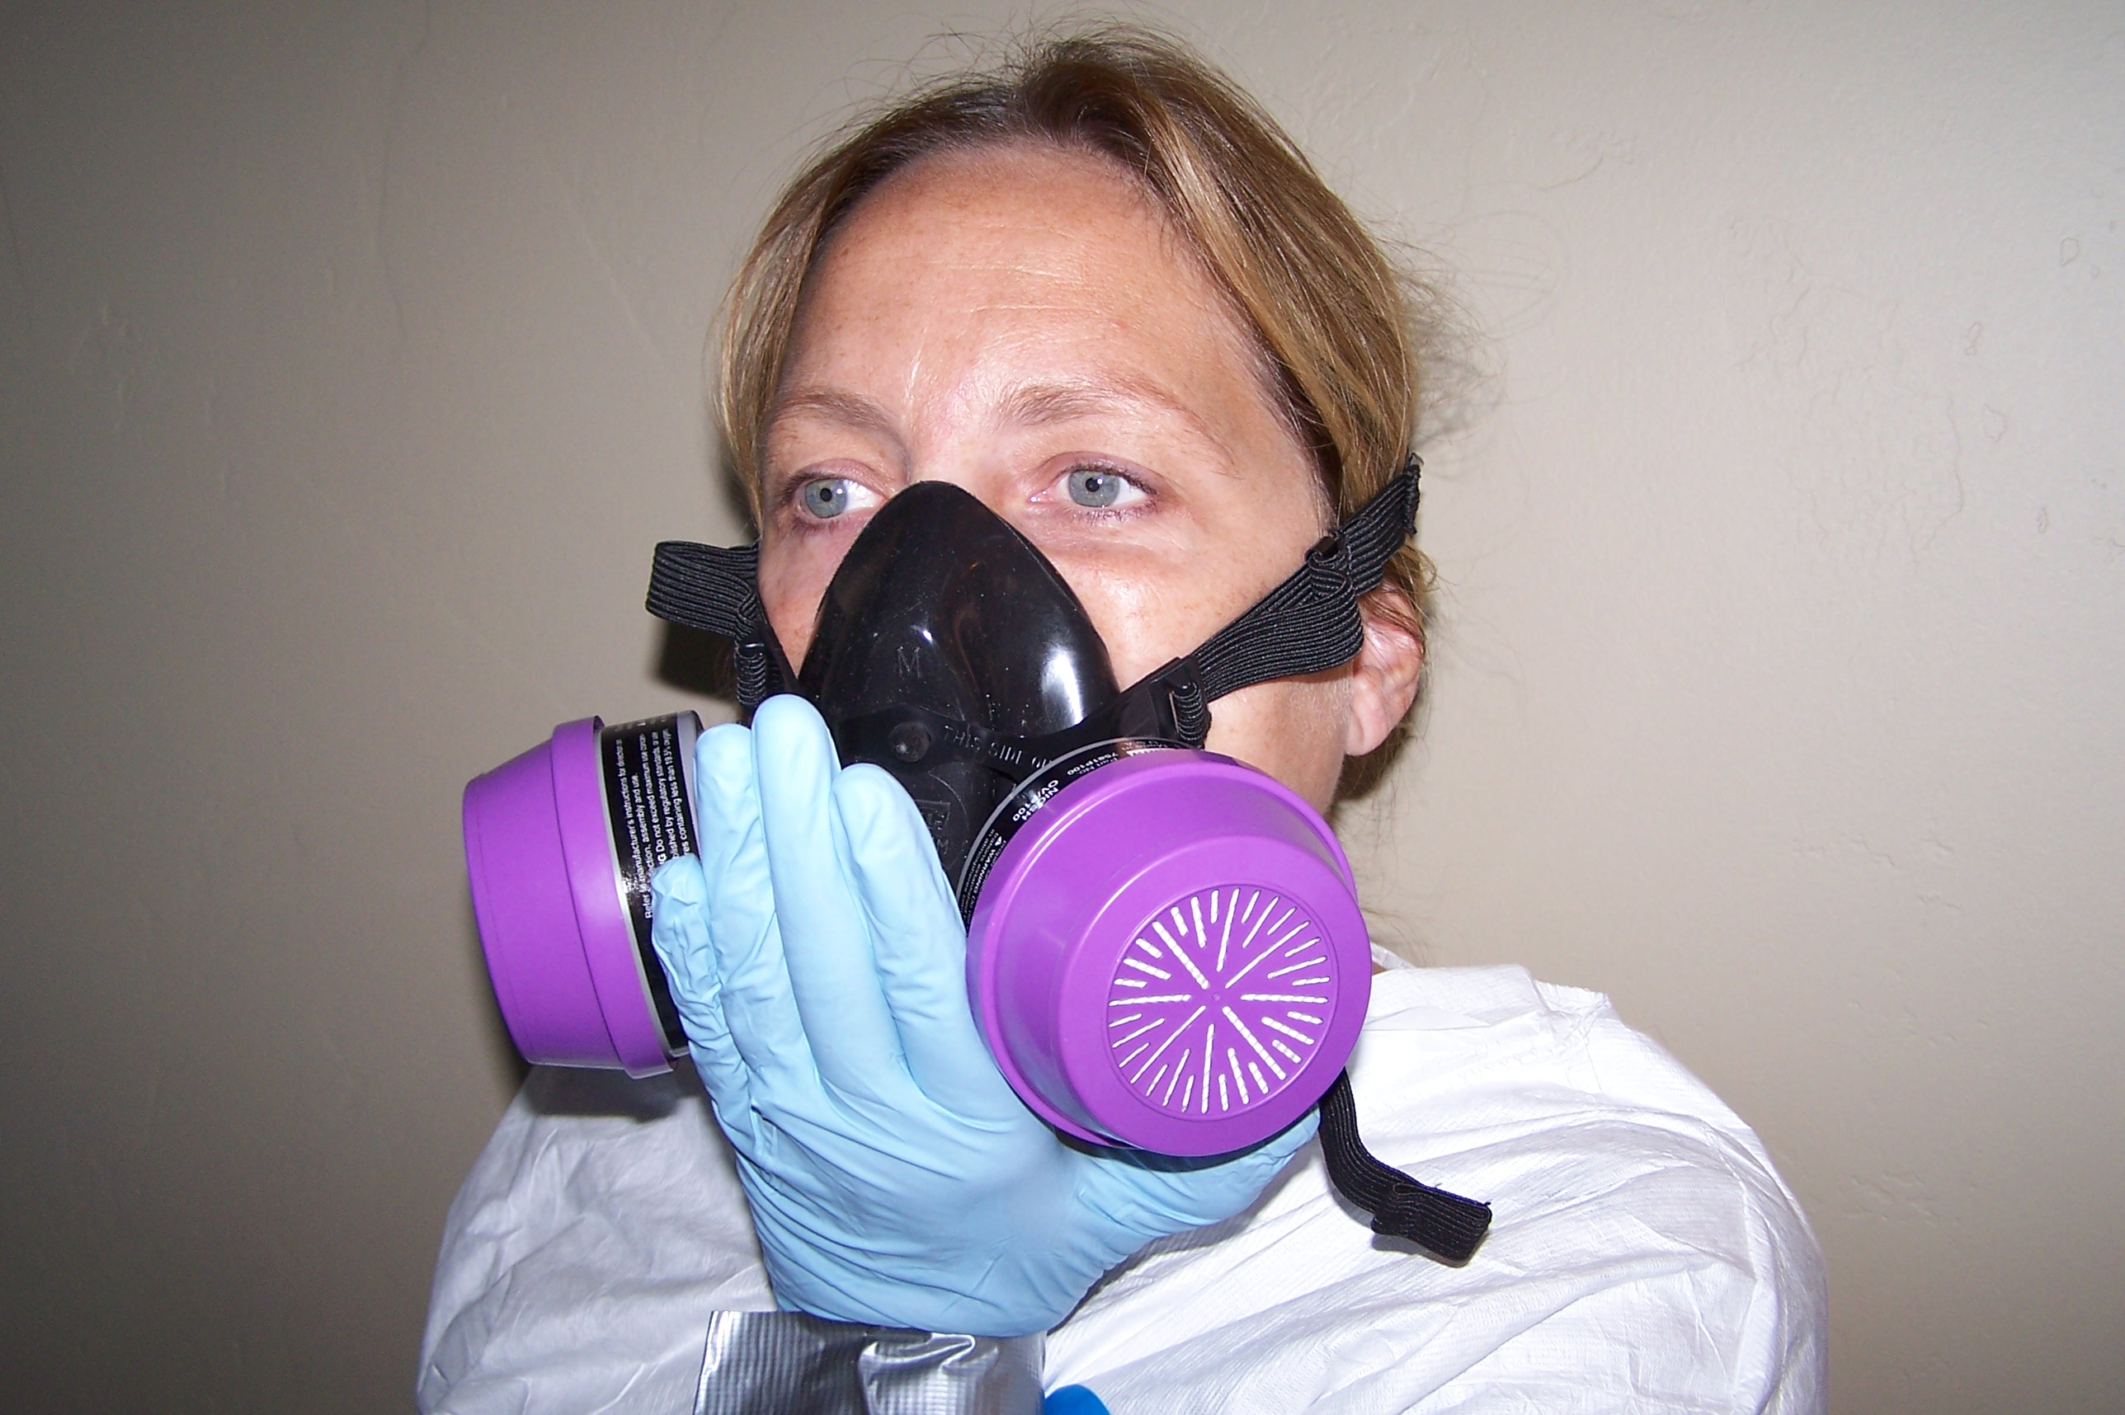
Qualitative Fit-Testing
29 CFR 1910.134 (f)(2) states, “The employer shall ensure that an employee using a tight-fitting facepiece respirator is fit-tested prior to initial use of the respirator, whenever a different respirator facepiece (size, style, model or make) is used, and at least annually thereafter.” In addition, changes in the employee’s physical condition that could affect respirator fit, such as facial scarring, dental changes, cosmetic surgery or an obvious change in body weight, would indicate the need for further fit-testing.
29 CFR 1910.134 defines a qualitative fit test as “A pass/fail test to assess the adequacy of respirator fit that relies on the individual’s response to the test agent.” This test is used only to fit-test negative pressure air purifying respirators that must achieve a fit factor of 100 or less. If your fit-test is due, ask a colleague who is competent to perform this fit-test (This individual needs no special certification) or the Respiratory Protection Program Administrator to fit-test you with the form on the following page. Each blank box should be initialed by the respirator wearer to acknowledge understanding and completion of the required training. If any items listed on the form are not completely understood, please refer to Module 3(b) Respiratory Protection or use the integrated e-mail to ask questions of one of our instructors. The person performing the fit-test should sign and date the bottom of the form and the form should be kept in the employee’s file until the next fit-test is performed.

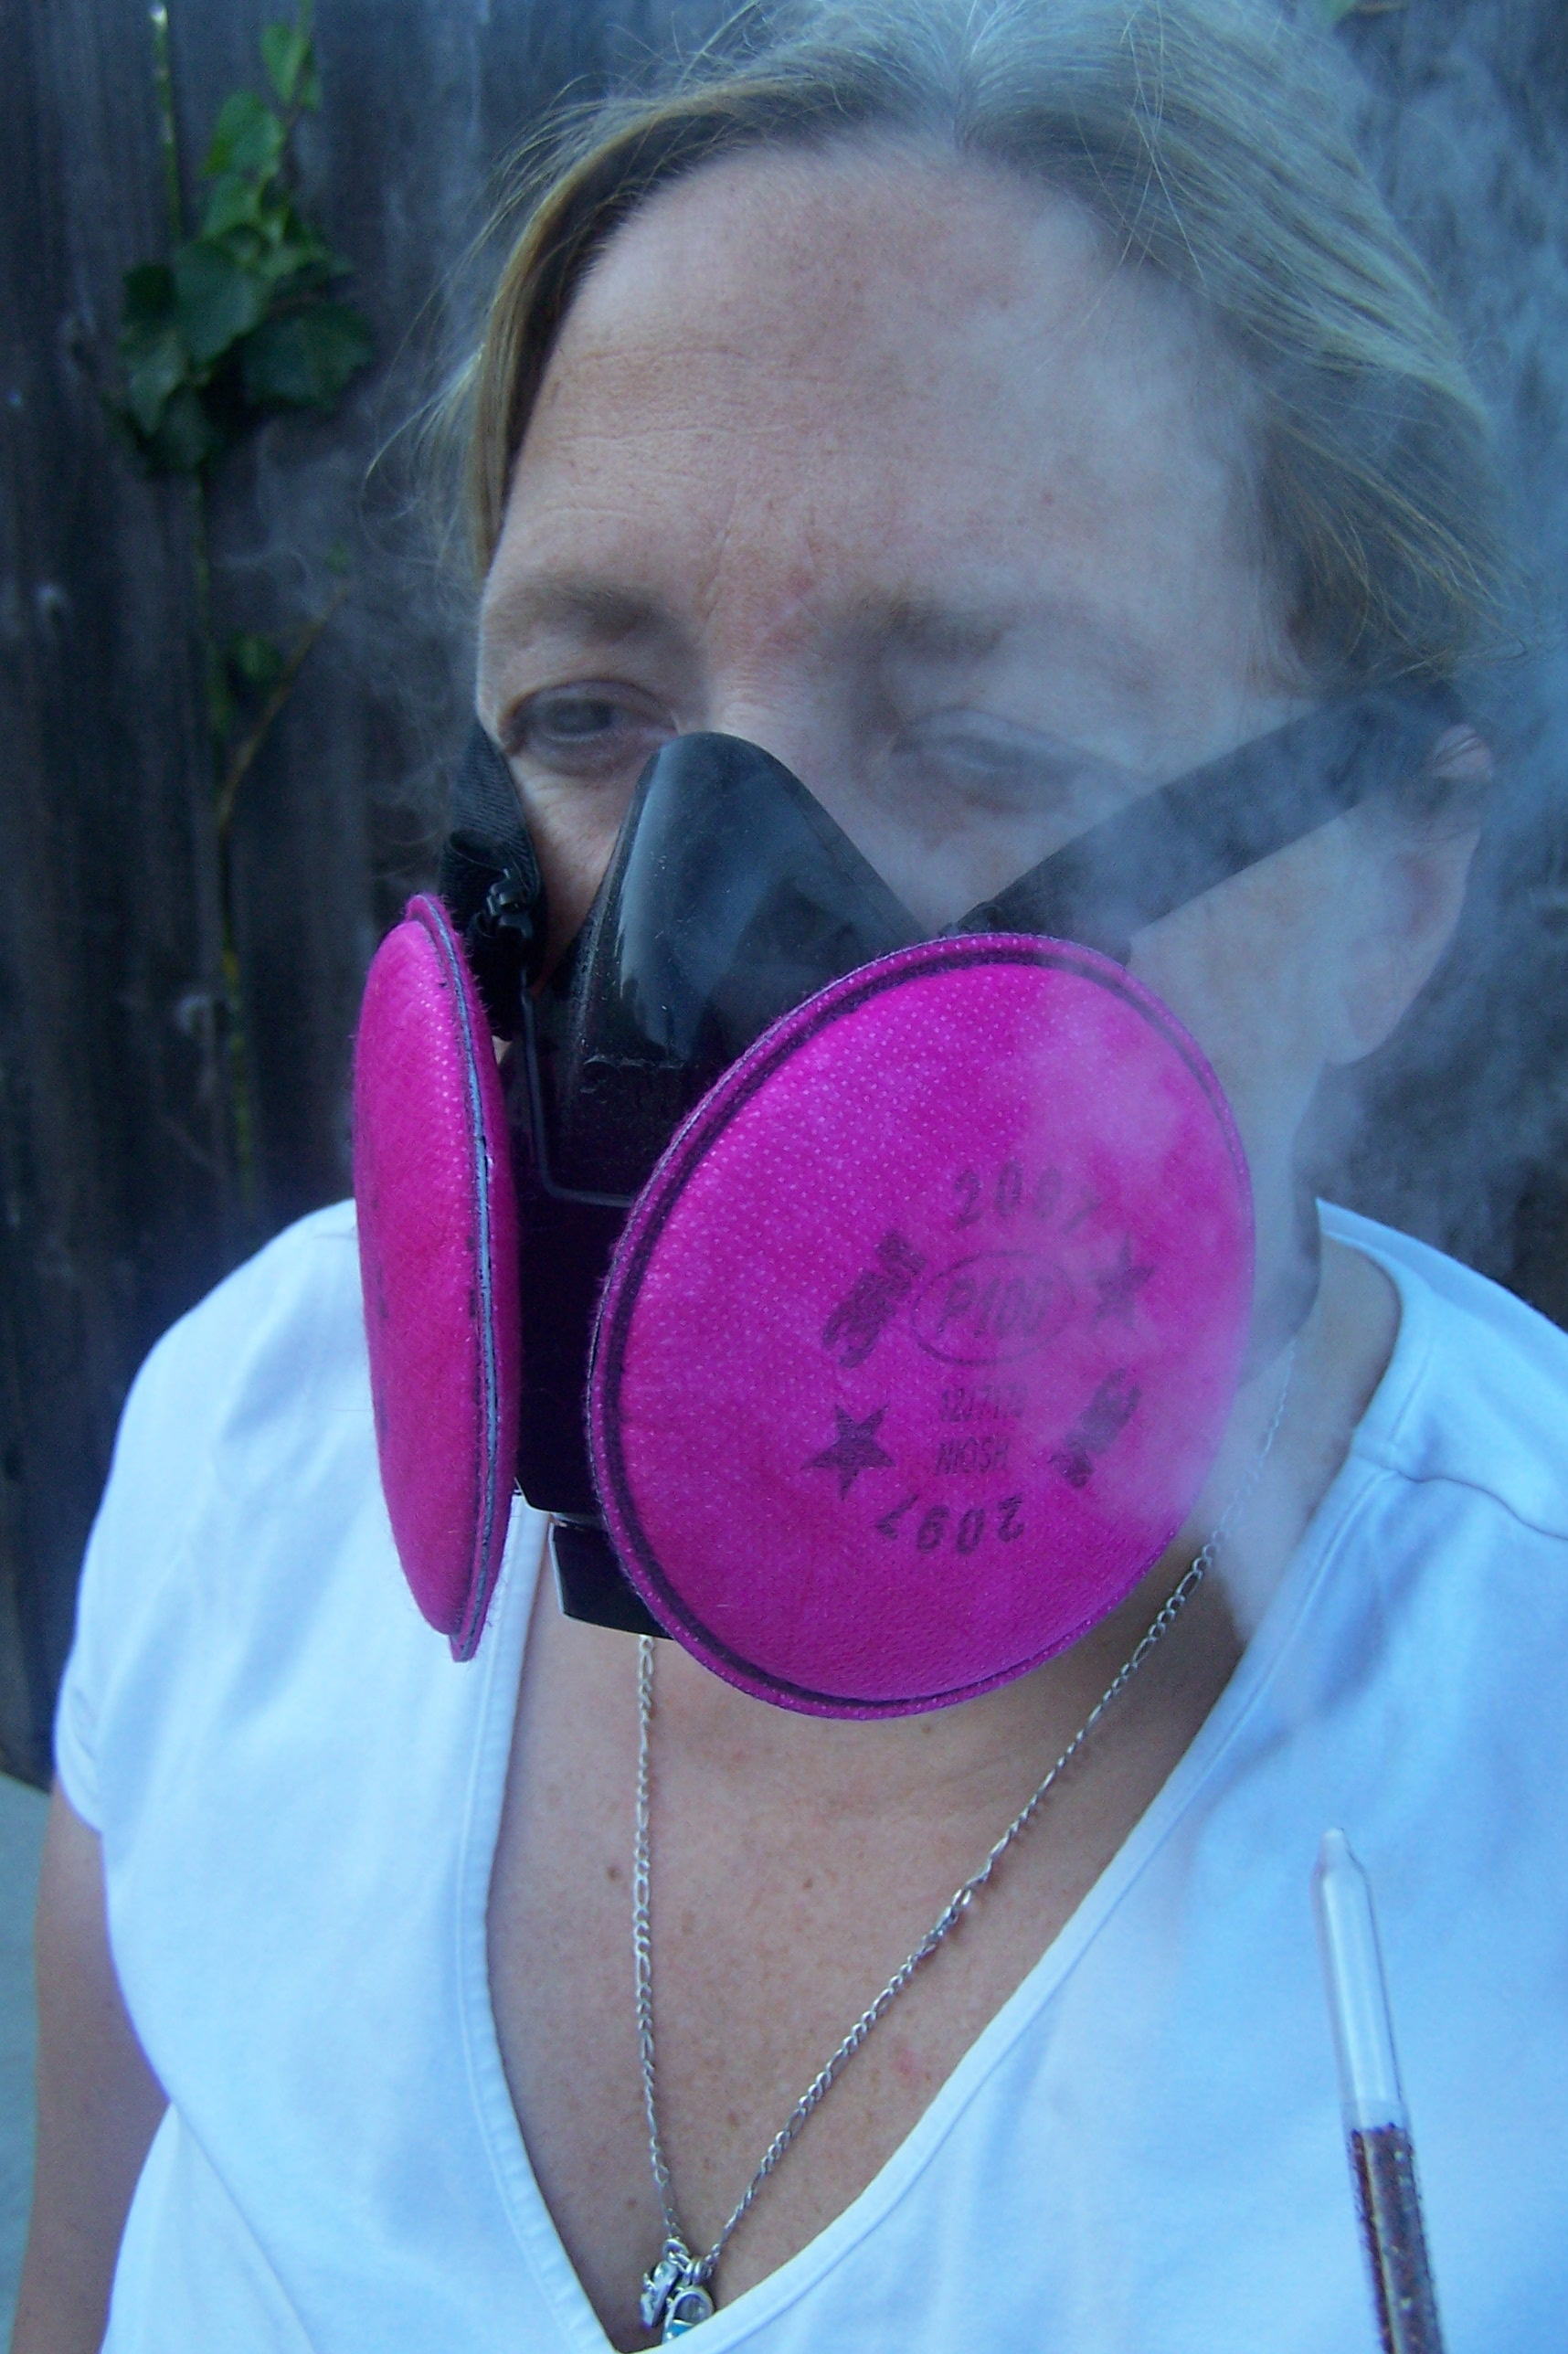
RESPIRATORY PROTECTION TRAINING
ACKNOWLEDGMENT AND QUALITATIVE FIT TEST FORM
Employee Name: Employee I.D.
Employer: Project:_______
Project #: Site:
Make: Model: Type (HF/FF) Size | Employee Initials  and Date
Fit Test Date: Performed by:
1. I have been informed in and understand the selection, use,
and limitations of AIR PURIFYING respiratory protection.
2. I have been informed in and understand the selection, use,
and limitations of SUPPLIED AIR respiratory protection. (Initial
if applicable).
3 I understand that I must perform a positive and negative
pressure check each time I don a respirator face mask and
how improper fit, usage or maintenance can compromise the
protective effect of the respirator.
4. I understand that I must be tested annually for proper
respirator face mask fit prior to use of respiratory protection
in hazardous or potentially hazardous atmospheres.
5. I understand that I shall not use air purifying respiratory
protection in oxygen deficient or IDLH atmosphere.
6. I understand that I must be medically qualified, as stated by
my employer’s physician, prior to use of respiratory protection.
7. I understand how to recognize medical signs and symptoms
that may limit or prevent the effective use of respirators.
8. I understand that facial hair, corrective eye wear or any other
obstacle shall not interfere with the direct contact of a
respiratory face seal surface and skin surface of the face.
9. I have been trained in the cleaning, inspection, maintenance
and storage of the respiratory protection assigned to me and
understand that it is my responsibility to maintain assigned
respiratory protection in a clean and approved condition.
10. I understand how to use the respirator effectively in emer-
gency situations including situations in which the respirator
malfunctions.

*Fit testing is to be performed with isoamyl acetate on organic vapor cartridges, irritant smoke on HEPA filtered cartridges or P100 series particulate filters, or saccharin solution, or Bitrex™ solution on respirators equipped with either 95, 99 or 100 series filters. At minimum, the following exercises must be performed for one minute each: normal breathing, deep breathing, moving head side-to-side, moving head up and down, bending over or jogging in place, and talking while breathing normally. Note that for the irritant smoke test, no form of enclosure is to be used while the other methods all require use of an enclosure.
Fit tested by:____________________________ Date:__________
This form should be retained in the employee’s file until the next fit test is administered.

